STUDENT NAME:MAUREEN WAIRIMU
ADM NO:BSCCS/2025/68877
COURSE:COMPUTER SCIENCE
UNIT TITLE: ETHICAL HACKING
UNIT CODE: BIT 4139.
LECTURER NAME: MR MICHAEL NYORO
SELECTED TOOL:NMAP.

Contents
Fig1:Setting up environment variables 3
Fig2:Nmap installed 3
Fig 3:Ping scan Address 192.168.1.0/24 4
Fig4:Port scanning:192.168.1.50 5
Fig5:Footprinting 5
Student reflection: 5
STEPS IN ETHICAL HACKING 5
IDENTIFYING TARGET INSTITUTION 5
Domain information: 6
Subdomains: 6
Domain registrar 6
IP Address 7
Email patterns 7
Technologies running: 8
Leaked credentials: 8
Student reflection 8
Findings 9
Security Risks 9
Task 2 9
SCANNING AND ENUMARATION 9
Scanning ports: 9
OS version scan: 10
Student reflection 12
Week 6: Vulnerability Assessment and Scanning 12
Practical Task 1 12
Basic Vulnerability Scan 12
Practical Task 2 12
Vulnerability Research Assignment 12
Research five recent vulnerabilities. 12
Practical Task 3: Organizational Vulnerability Assessment Plan 14
Advanced Practical Task 14
Vulnerability tracking spreadsheet 14
Challenge Task 14

WEEK ONE:
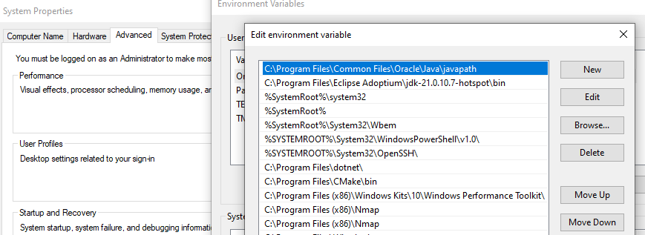
Fig1:Setting up environment variables.
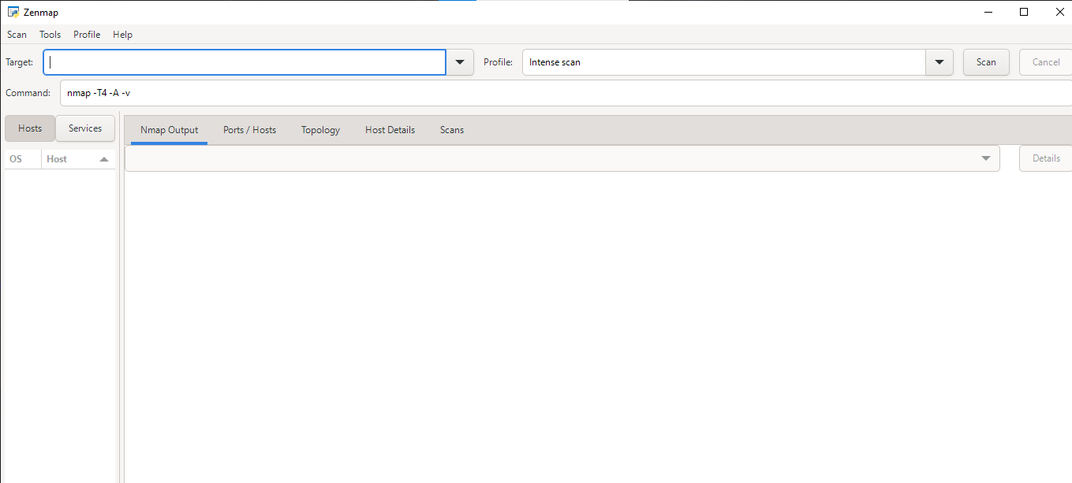
Fig2:Nmap installed.
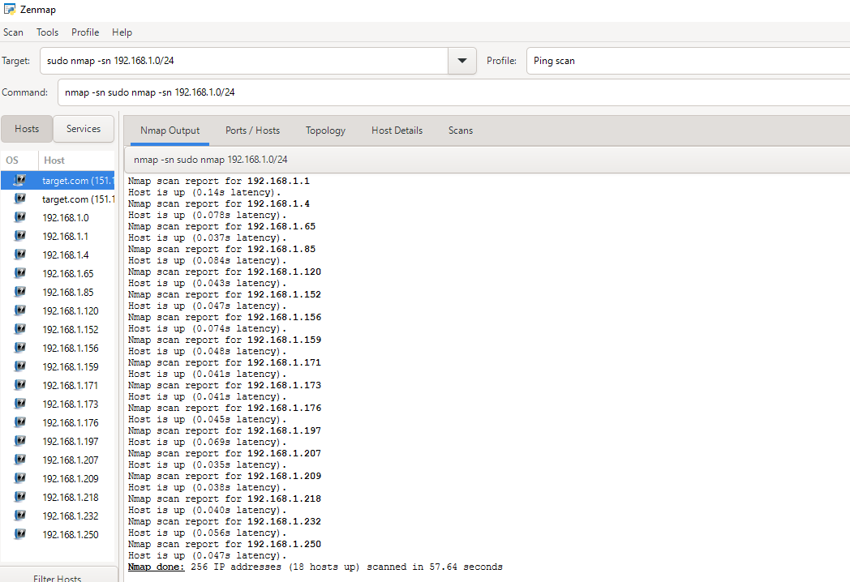

Fig 3:Ping scan Address 192.168.1.0/24
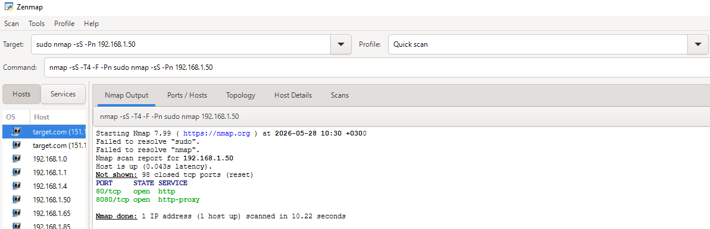

Fig4:Port scanning:192.168.1.50
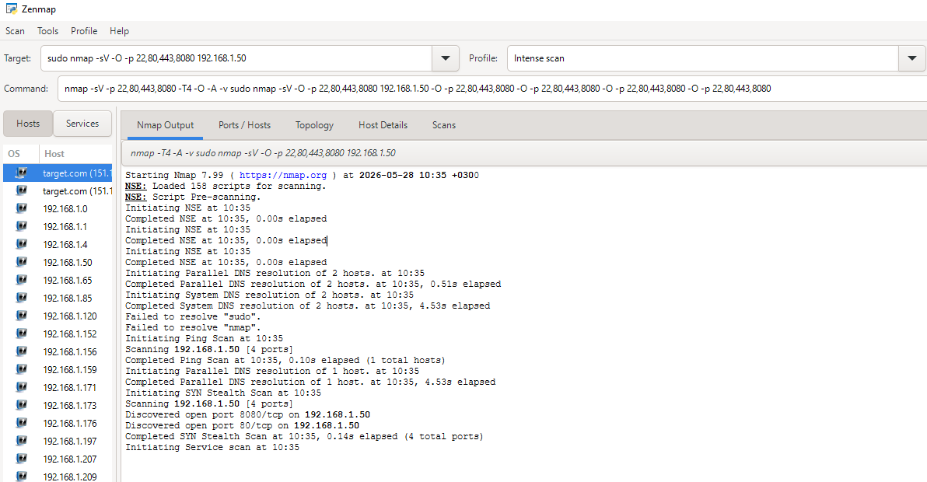

Fig5:Footprinting

Student reflection:
What I have learnt while in week one is how to set up a penetration tool,perform basic scans using ip address and determine the output given .
STEPS IN ETHICAL HACKING.
IDENTIFYING TARGET INSTITUTION.

Domain information:
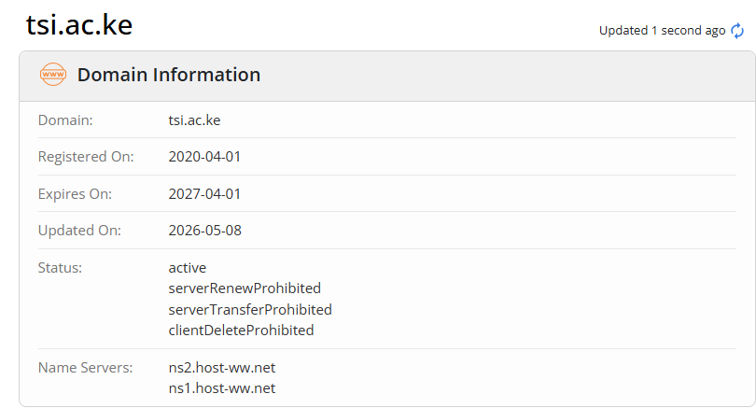

Subdomains:
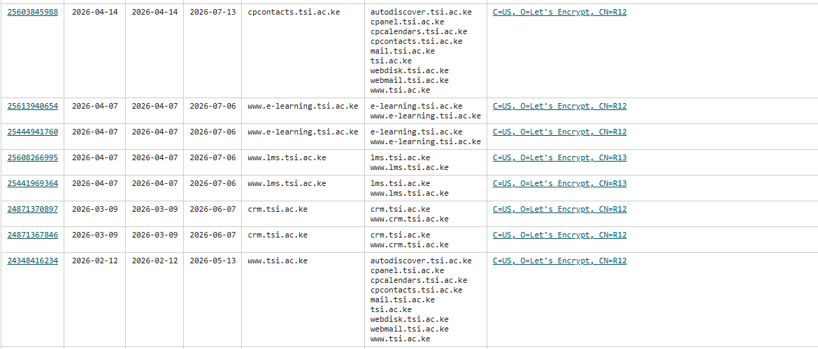
Domain registrar:
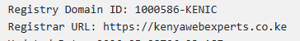

IP Address
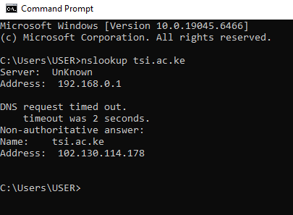

Email patterns
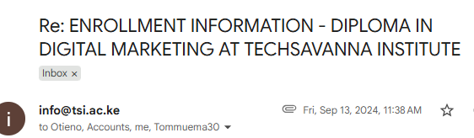

Technologies running:
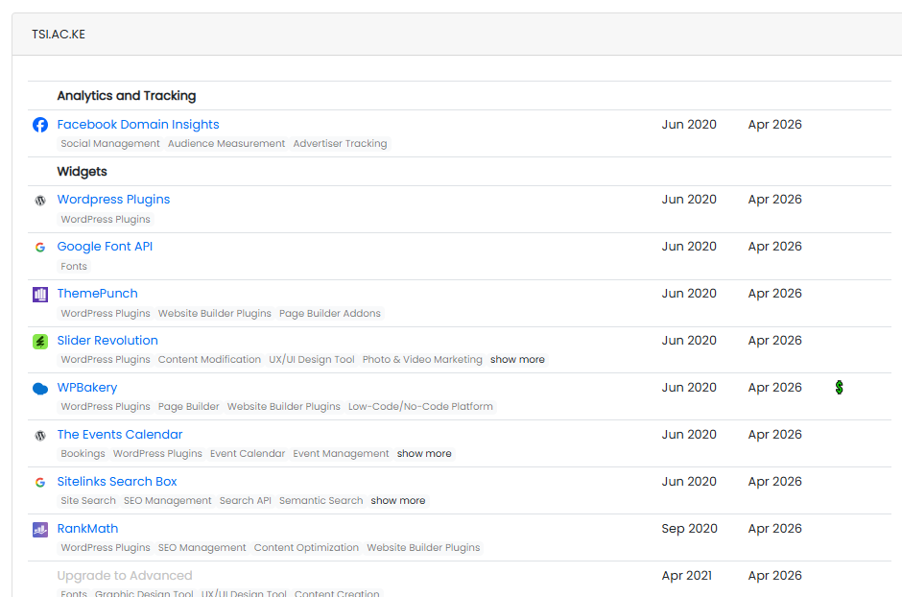

Leaked credentials:
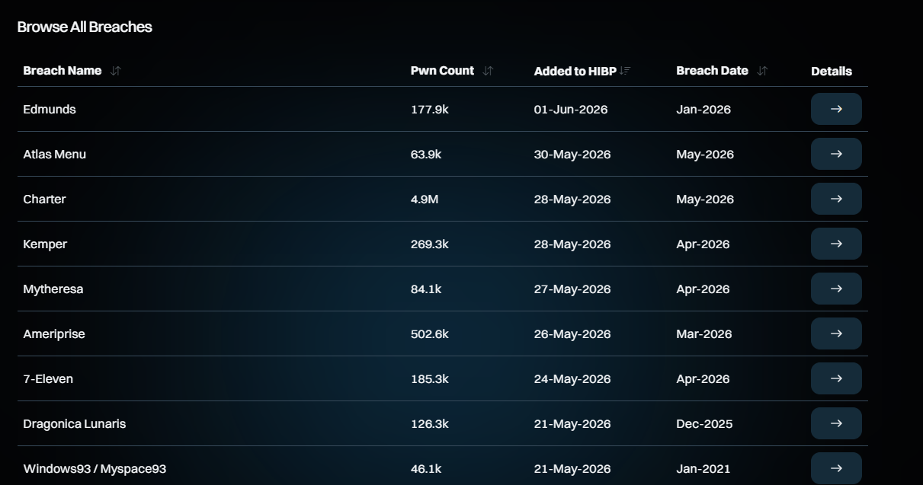
Student reflection:
What I have learnt while perfoming task one is how to gather information from publicly accessible tools such as WHOIS,OSNIT which provides details such as domain registrar ,ip address and others.This helps you understand the system better such as when it was registered,updated and when it expires.This helps one find opportunities for vulnerabilities recognize the patterns.All this basically help the hacker get their objectives in place.

Findings
- Domain and IP publicly accessible.
- Predictable email format
- Technologies identified through headers and nmap scans

Security Risks
- Predictable email format increases risk
- Subdomains may have weaker security controls.

Task 2

SCANNING AND ENUMARATION

Scanning ports:
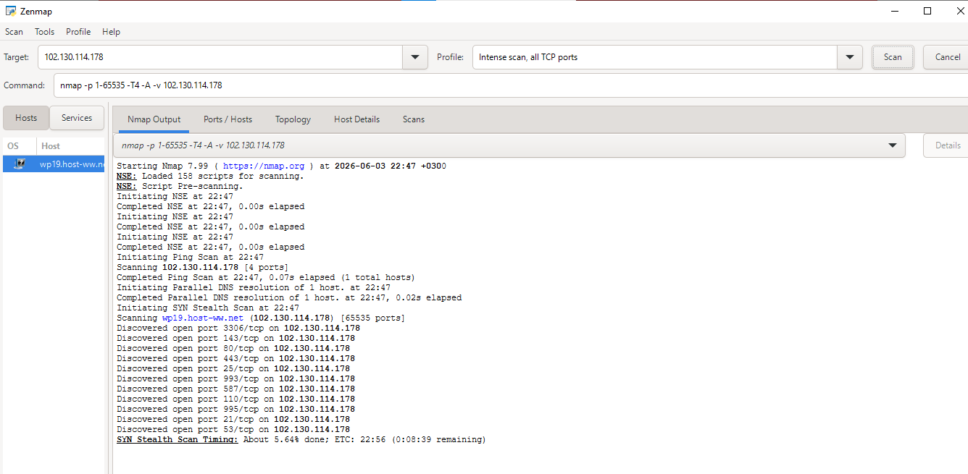

OS version scan:
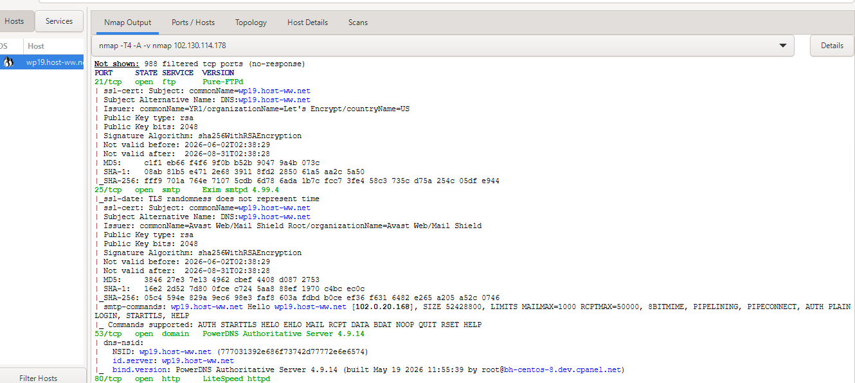
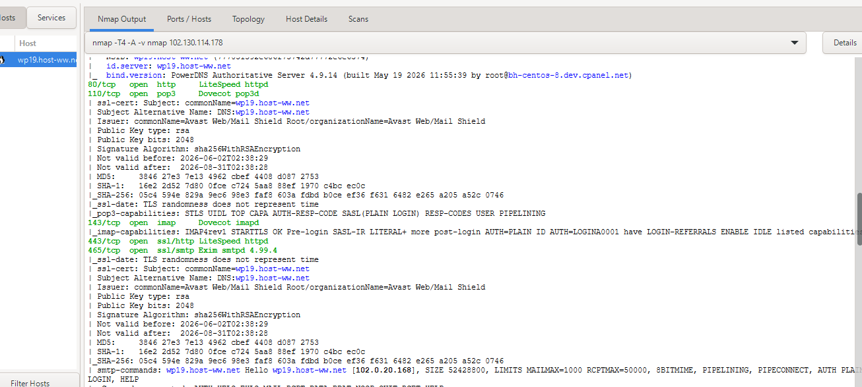
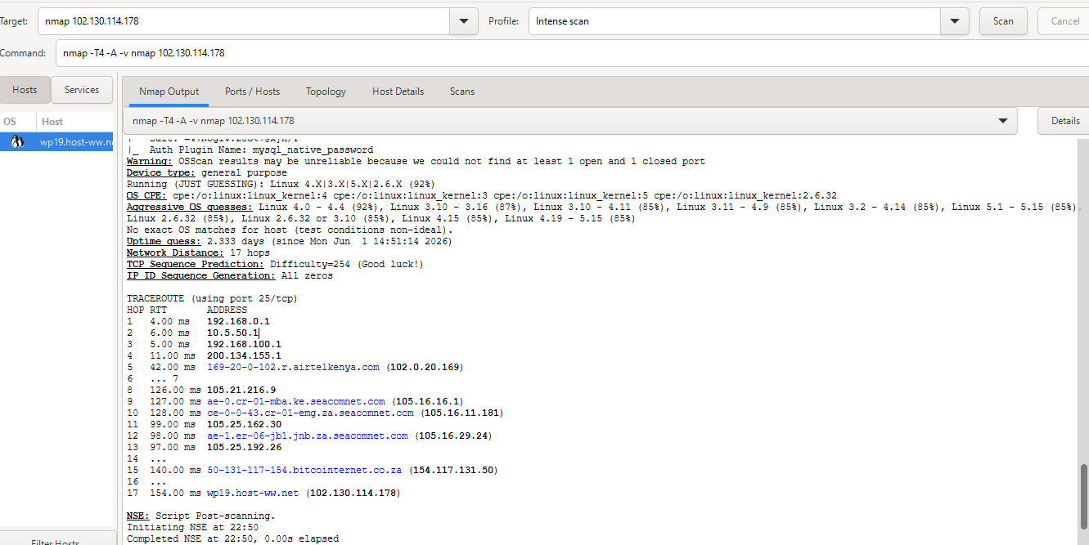
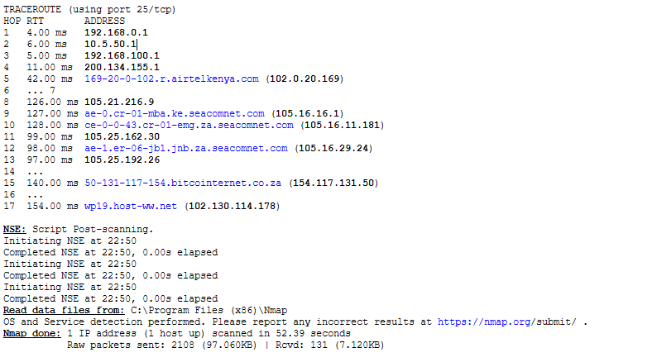Enumarate shared folders:
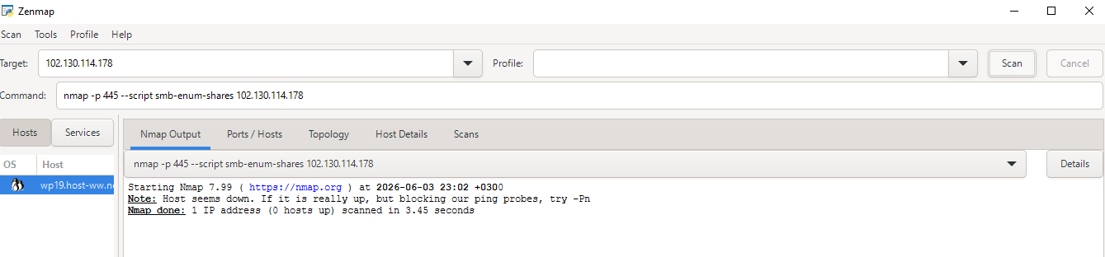
Student reflection:
What I have learnt while performing task 2,is how to identify live host of active work stations,open ports and operation system versions.Some of the challenges were that some ports were blocked so you could not get access to the information required.

Week 6: Vulnerability Assessment and Scanning

Practical Task 1

Basic Vulnerability Scan
Active Hosts & Open Ports Discovery
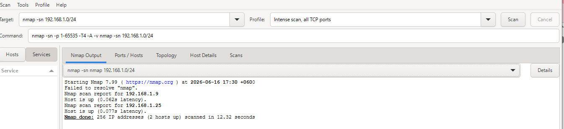
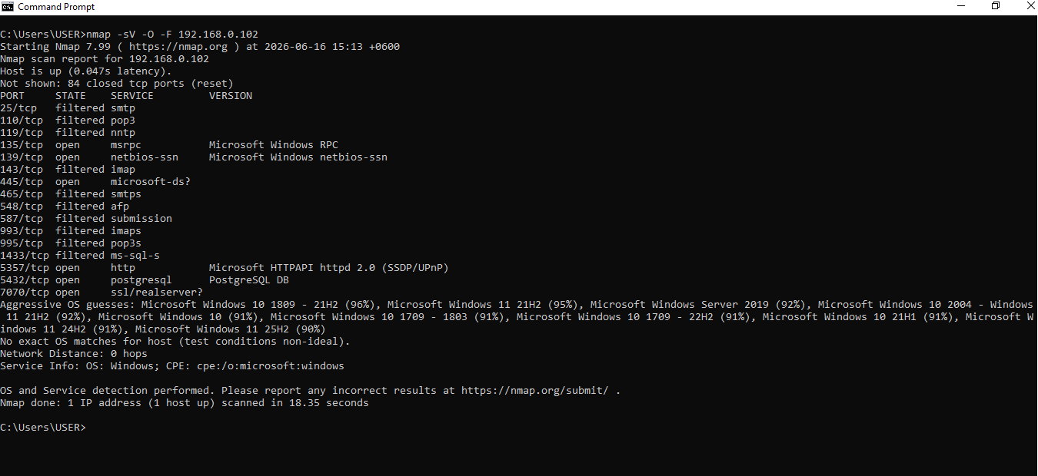

Practical Task 2

Vulnerability Research Assignment

Research five recent vulnerabilities.
CVE Number | Description | Severity (CVSS) | Potential Impact | Mitigation Strategy
CVE-2020-0601 | A spoofing vulnerability existing in the way Windows CryptoAPI (Crypt32.dll) validates Elliptic Curve Cryptography (ECC) certificates. | High (8.1) | Attackers can sign malicious executables or spoof secure HTTPS connections, making malware look like legitimate trusted software. | Install the January 2020 Microsoft Security updates for Windows 10, Windows Server 2016, and 2019.
CVE-2021-34527 | A remote code execution vulnerability found in the Windows Print Spooler service when it improperly handles unauthenticated file write operations. | Critical (8.8) | An unauthenticated attacker can gain full domain administrator privileges, modifying directories and installing unauthorized applications | Disable the Windows Print Spooler service on critical domain controllers and infrastructure servers where printing functionality is not required.
CVE-2014-0160 | A severe information disclosure flaw in the OpenSSL TLS Heartbeat extension that allows reading sensitive memory buffers of affected servers. | High (7.5) | Exposure of secret private cryptographic keys, user session cookies, unencrypted passwords, and confidential communications. | Upgrade OpenSSL to version 1.0.1g or newer
CVE-2026-11645 | Out-of-bounds memory access in Chrome’s V8 JavaScript engine. Exploited via crafted HTML pages | High (8.8) | Remote code execution inside browser sandbox; compromise of user sessions. | Update Chrome to latest version
CVE-2026-45586 | Windows Collaborative Translation Framework (CTFMON) privilege escalation | Critical | Local attackers gain system privileges, enabling full device takeover | enable least privilege and monitor for abnormal privilege escalation.

Practical Task 3: Organizational Vulnerability Assessment Plan
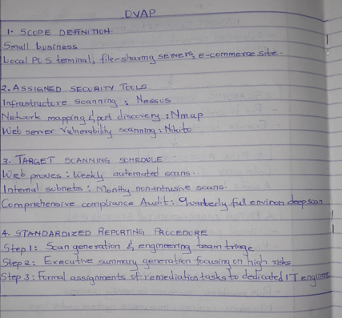

Advanced Practical Task

Vulnerability tracking spreadsheet
Vulnerability Name | Risk Level | Status | Assigned Personnel | Resolution Date
React2Shell RCE (CVE-2025-8671) | Critical | Resolved | Emma (Web DevSecOps) | 10/06/2026
Default Admin Credentials | Critical | Resolved | M. Wairimu (Dev) | 2026-06-13
Outdated Apache Web Server | High | Open | J. Doe (System Admin) | 17/06/2026
Open FTP Port | Medium | Open | A. Smith(Network Admin) | 21/06/2026

Challenge Task
Vulnerability Management Framework for an organization
